Walk MS Folsom 2018
Sunday, April 15, 2018

Talk in is on W6EK (see Event Frequencies below). We will meet at Sutter Street Plaza (921 Sutter Street) in Historic Folsom. Net Control should show at 0800. Rest Stops should report to Net Control by 0830 to pick up their tee shirt for identification.

The walk starts at 0900. Be ready to operate by then.

Net Control should try to set up their station in the southwest corner of the parking lot between the Railroad Turntable and Leidesdorff Street. Net Control will keep a log of important transmissions.

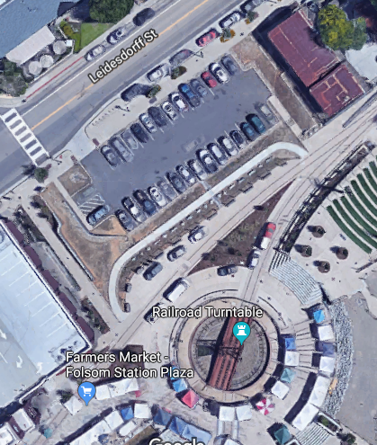

Here is the MS website for the event: http://main.nationalmssociety.org/site/TR/Walk/CANWalkEvents?pg=entry&fr_id=29389

The Walk MS manager is Michere Schott.

There are two walk routes: 1 mile and 3 mile.

Rest Stop locations are provided on this map:
http://main.nationalmssociety.org/images/content/pagebuilder/2018_Washout_Route_Folsom_1-5k_Route_Map.jpg

STATION NAME | OPERATORS
Net Control | Greg Dolkas KO6TH, Matt Pauly KK6YMJ
Rest Stop 1 | Dennis Gregory WU6X, Joe Ramirez KN6FH
Rest Stop 2 | Les Green KG6NME, Jim Jupin WA8MPA
Rest Stop 3 | Brian Gohl AI6US, Bob Shuken W6USB
Bicycle | Mike Perry KK6GLP

SFARC EVENT FREQUENCIES
CHANNEL | NAME | FREQUENCY | OFFSET | TONE
1 | W6EK | 145.430 | - | 162.2
2 | Roseville | 146.640 | - | 156.7
3 | Loomis | 146.985 | - | 94.8
4 | K6IOK | 145.130 | - | 114.8
5 | TAC 1 | 147.570
6 | TAC 2 | 145.580
7 | TAC 3 | 146.490
8 | TAC 4 | 146.580
9 | TAC 5 | 146.550
10 | TAC B | 446.500
11 | TAC C | 441.000

We will use TAC 1 147.570 Simplex unless directed to change by Net Control. Stations are close enough for HT Simplex use.

Net Control will direct any frequency changes. Changes will be made by Name (i.e. W6EK, TAC 1, etc.) and not Channel Number or Frequency. We do not want to reveal our frequencies, to avoid others listening in.

This is a directed net. Communications will go through Net Control.

Bring a hat and sunscreen. Water should be available at all locations.

Important: Do not transmit the names of any participants. Personal information is not to be given over the air. Identify the participant by number only when making a transmission.

If you have any questions or comments, please use the "Reply All" feature so others may see them.

Thank you for participating!

