Walk MS Folsom 2019
Sunday, May 5, 2019

Talk in is on W6EK (see Event Frequencies below). Net Control should show at 0800 to Sutter Street Plaza (921 Sutter Street) in Historic Folsom. Rest Stops should report to Net Control by 0830 if they want to pick up their tee shirt for identification. The walk starts at 0900, please be in place and ready to operate by then.

Net Control should try to set up their station in the southwest corner of the parking lot between the Railroad Turntable and Leidesdorff Street. Net Control will keep a log of important transmissions.

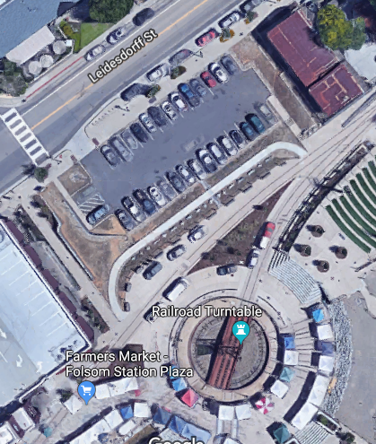

Here is the MS website for the event with map of rest stops:

https://secure.nationalmssociety.org/site/TR?fr_id=30398&pg=informational&sid=13242

The Walk MS manager is Michere Schott.

There are two walk routes: 1 mile and 3 mile.

STATION NAME | OPERATORS
Net Control | Greg KO6TH, Andrew K6OP
Rest Stop 1 | Dennis WU6X
Rest Stop 2 (some walking required) | Jim WA8MPA
Rest Stop 3 | George KG6LSB, Gary N6UWQ
Bicycle | -

SFARC EVENT FREQUENCIES
CHANNEL | NAME | FREQUENCY | OFFSET | TONE
1 | W6EK | 145.430 | - | 162.2
2 | Roseville | 146.640 | - | 156.7
3 | Loomis | 146.985 | - | 94.8
4 | K6IOK | 145.130 | - | 114.8
5 | TAC 1 | 147.570
6 | TAC 2 | 145.580
7 | TAC 3 | 146.490
8 | TAC 4 | 146.580
9 | TAC 5 | 146.550
10 | TAC B | 446.500
11 | TAC C | 441.000

We will use TAC 2 145.580 Simplex unless directed to change by Net Control. Stations are close enough for HT Simplex use. Net Control will direct any frequency changes. Changes will be made by Name (i.e. W6EK, TAC 1, etc.) and not Channel Number or Frequency. We do not want to reveal our frequencies, to avoid others listening in.

This is a directed net. Communications will go through Net Control.

Bring a hat and sunscreen. Water should be available at all locations.

Important: Do not transmit the names of any participants. Personal information is not to be given over the air. Identify the participant by number only when making a transmission. We are providing volunteer communications support. Contact Net Control with any questions.

If you have any questions or comments, please use the "Reply All" feature so others may see them.

Thank you for participating!

